**WorkSheet:- 2.2**

**Student Name:** Vivek Kumar **UID:** 21BCS8129

**Branch:** BE-CSE (LEET) **Section/Group:** 20BCS-809/A

**Semester:** 4th Sem **Date of Performance:** 29/03/2022

**Subject Name:** SE Lab **Subject Code:** 20CSP-255

**AIM: -** [**Bank ATM UML use case diagrams examples**](https://www.uml-diagrams.org/bank-atm-uml-use-case-diagram-example.html?context=uc-examples)

**Purpose**: Describe use cases that an automated teller machine (ATM) or the automatic banking machine (ABM) provides to the bank customers.

**Summary**: Customer uses a bank ATM to check balances of his/her bank accounts, deposit funds, withdraw cash and/or transfer funds (use cases). ATM Technician provides maintenance and repairs to the ATM.?

**Solution: -** Here I have provided all the functionality in the single UML diagram.

Such as User will insert the CARD first in to the ATM machine.

Then it will ask for the authentication. And that authentication will get verified from the Bank System or Server.

User will select the Transaction Mode such as Check Balance, Deposit Funds, Transfer Funds, Withdraw Balance and Change Pin.

Change pin will get verified from the Bank Server.

Deposit & Transfer Funds as well as Withdraw Balance will re direct to Enter Amount section, where User will enter the Amount and Bank server will verify it.

ATM Machine will Dispense the cash. Then User will Accept the Cash.

ATM Machine will generate the Receipt. Then User will accept the Receipt.

ATM Technician Will be Maintaining the ATM Machine, which includes Repairing, Diagnostic and Upgrades.

ATM Technician will also Repair the ATM Machine Which includes Diagnostic, i.e., Any kind of Functionality issues or anything.

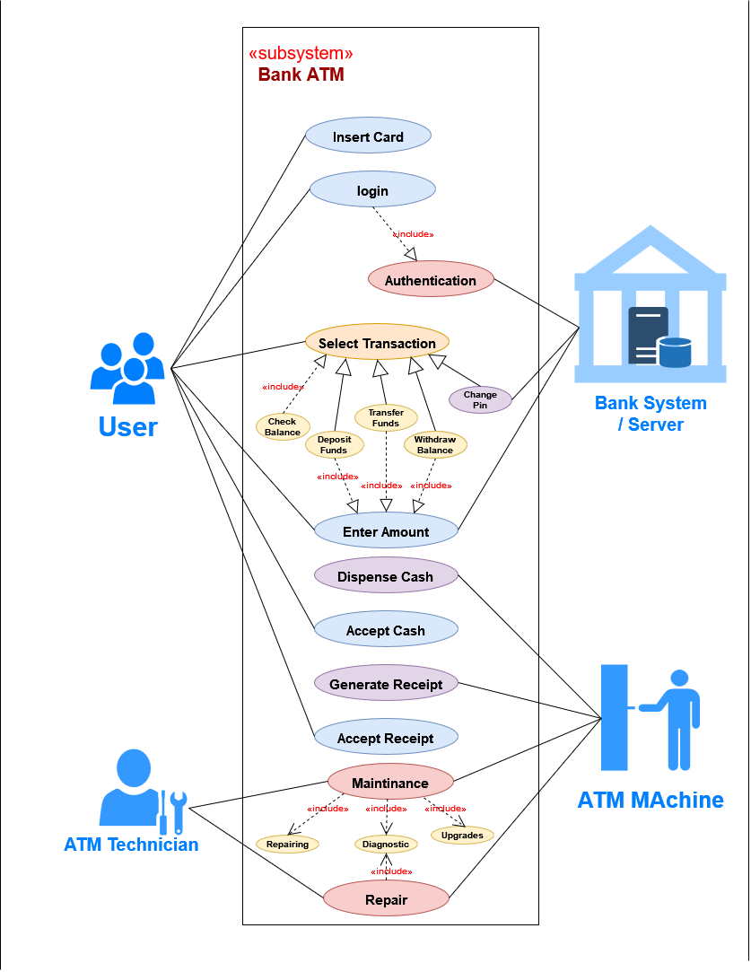**Use Case Diagram:**